Student Name: Sahil Hans UID: 25MCI10088
Branch: M.C.A(A.l & M.L) Section/Group: MAM-1 A
Semester: Second Sem Date of Performance:12/01/2026
Subject Name: TECHINCAL SKILLS Subject Code:

WORKSHEET 5
AIM: To gain hands-on experience in creating and using cursors for row-by-row processing in a database, enabling sequential access and manipulation of query results for complex business logic. (Company Tags: Infosys, Wipro, TCS, Capgemini)
S/W Requirement: Oracle Database Express Edition and pgAdmin
OBJECTIVES:
- Sequential Data Access: To understand how to fetch rows one by one from a result set using cursor mechanisms.
- Row-Level Manipulation: To perform specific operations or calculations on individual records that require conditional procedural logic.
- Resource Management: To learn the lifecycle of a cursor: Declaring, Opening, Fetching, and importantly, Closing and Deallocating to manage system memory.
- Exception Handling: To handle cursor-related errors and performance considerations during large-scale data iteration.

Practical / Experiment Steps
Step 0: Setup (Creation of Table)
CREATE TABLE Employee (
emp_id SERIAL PRIMARY KEY,
emp_name VARCHAR(50),
salary NUMERIC(10,2),
experience INT, -- Years of experience
performance_score INT -- Rating out of 10
);
Inserting Sample Values
INSERT INTO Employees (emp_name, salary, experience, performance_score) VALUES
('Amit', 40000, 2, 6),
('Neha', 60000, 5, 8),
('Rohit', 55000, 4, 7),
('Priya', 75000, 8, 9),
('Karan', 30000, 1, 5);

Output:
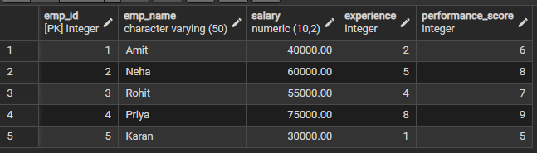

Step 1: Implementing a Simple Forward-Only Cursor
- Creating a cursor to loop through an Employee table and print individual records.

DO $$
DECLARE
emp_record RECORD; -- Variable to hold one row
emp_cursor CURSOR FOR -- Declare cursor
SELECT emp_id, emp_name, salary
FROM Employee;
BEGIN

OPEN emp_cursor; -- Open cursor

LOOP
FETCH emp_cursor INTO emp_record; -- Fetch one row

EXIT WHEN NOT FOUND; -- Exit when no more rows

RAISE NOTICE 'ID: %, Name: %, Salary: %',
emp_record.emp_id,
emp_record.emp_name,
emp_record.salary;
END LOOP;
CLOSE emp_cursor; -- Close cursor
END $$;

Output:
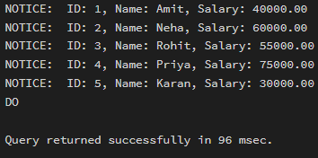
Step 2: Complex Row-by-Row Manipulation
- Using a cursor to update salaries based on a dynamic "Experience-to-Performance" ratio logic.
DO $$
DECLARE
emp_record RECORD;

-- Declare cursor
emp_cursor CURSOR FOR
SELECT emp_id, salary, experience, performance_score
FROM Employee;

increment_percent NUMERIC;
new_salary NUMERIC;

BEGIN

OPEN emp_cursor;

LOOP
FETCH emp_cursor INTO emp_record;

EXIT WHEN NOT FOUND;

/* Calculate increment percentage */
increment_percent :=
(emp_record.experience * emp_record.performance_score) / 10.0;

/* Calculate new salary */
new_salary :=
emp_record.salary +
(emp_record.salary * increment_percent / 100);

/* Update salary */
UPDATE Employee
SET salary = new_salary
WHERE emp_id = emp_record.emp_id;

/* Display update message */
RAISE NOTICE
'Employee ID: %, Increment: %%%, New Salary: %',
emp_record.emp_id,
increment_percent,
new_salary;

END LOOP;
CLOSE emp_cursor;

END $$;
Output:
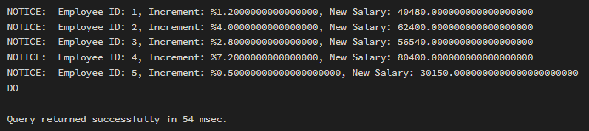

Step 3: Exception and Status Handling
- Ensuring the cursor handles empty result sets or termination signals gracefully.

DO $$
DECLARE
emp_record RECORD;

emp_cursor CURSOR FOR
SELECT emp_id, salary
FROM Employee;

BEGIN

OPEN emp_cursor;

LOOP
FETCH emp_cursor INTO emp_record;

EXIT WHEN NOT FOUND;

-- Intentionally raise exception if salary < 35000
IF emp_record.salary < 35000 THEN
RAISE EXCEPTION
'Salary too low for Employee ID: %',
emp_record.emp_id;
END IF;

RAISE NOTICE
'Processed Employee ID: %, Salary: %',
emp_record.emp_id,
emp_record.salary;

END LOOP;

CLOSE emp_cursor;

EXCEPTION
WHEN OTHERS THEN
RAISE NOTICE 'Exception Caught Successfully!';
RAISE NOTICE 'Error Message: %', SQLERRM;
RAISE NOTICE 'Execution stopped safely.';

END $$;
Output:
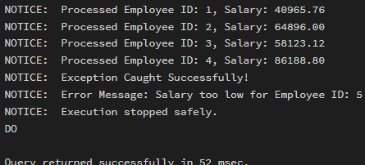

END $$;

Outcomes:
- Cursor Implementation: Students will be able to design, implement, and manage cursors to solve row-wise processing problems.
- Lifecycle Mastery: Students will demonstrate the correct syntax for declaring, opening, fetching, and closing cursors.
- Error Prevention: Students will understand how to properly handle row-by-row processing exceptions and prevent memory leaks via deallocation.
- Analytical Thinking: Students will be able to apply cursor-based logic to solve real-world scenarios like multi-level payroll adjustments or data migrations.

